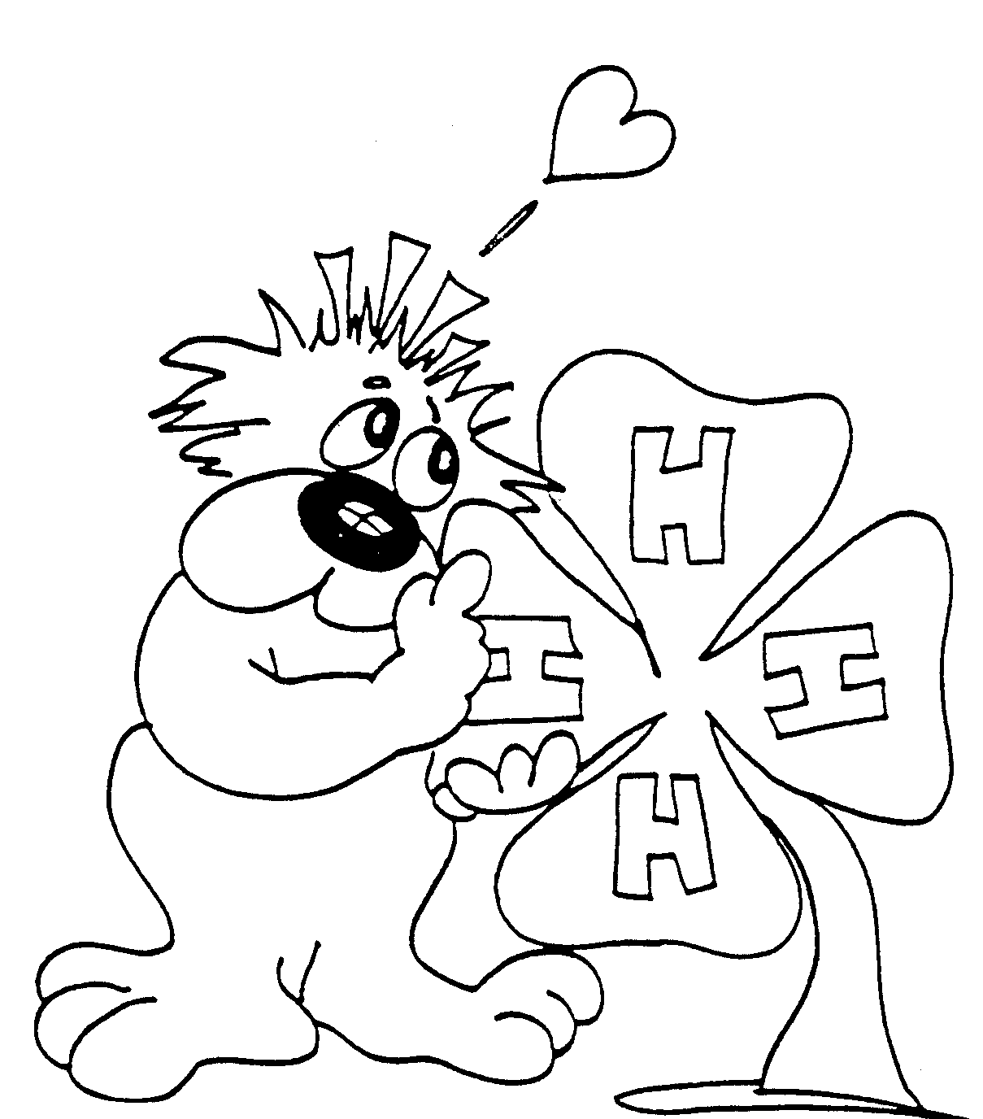
CLOVERBUD

RECORD BOOK

Name______________________ City ______________

Address ___________________4-H Age __________
(Age as of Oct. 1)
Birth Date _________________

Parents/Guardian _____________________________

Name of Club _________________________________

THIS IS ME


My Hair is ____________________________
My Eyes are __________________________
I am in _________ at ___________________
(Grade) (School)
My favorite Animal is ____________________
My Favorite Food is _____________________
My Favorite Sport is ____________________
More Me

There are ________ Members in My Family

_________ Brothers _________ Sisters

Family Autographs
____________________________________________________________________________________________________________________________________________________________________________________________________________

My Pet
I Have One

I Don’t Have One

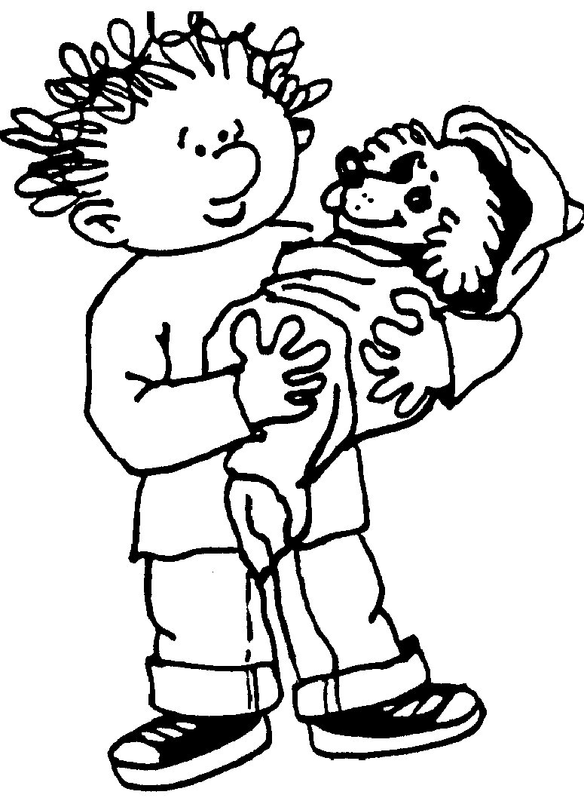
Fun Things I Do With My Pet Are:

Things I Do To Care For My Pet Are:
________________________________________

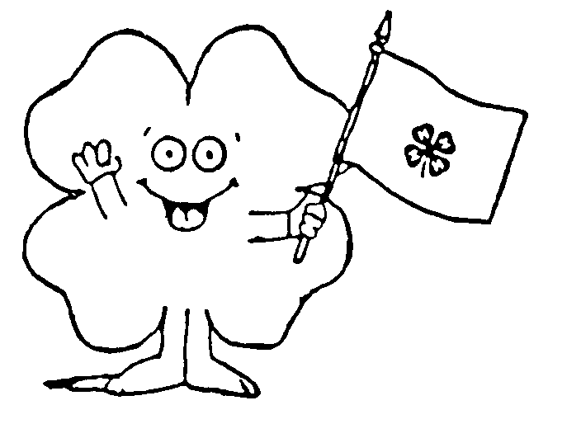

4-H PLEDGE

I Pledge My ____________ To Clearer Thinking,

My __________________ To Greater Loyalty,

My __________________Larger Service, And

My _________________ To Better Living, For

My Club, My Community, My Country,

And My World.

4-H Club Emblem: The Four-Leaf Clover
4-H Club Colors: Green And White
4-H Club Motto: To Make The Best Better


I JOINED 4-H BECAUSE:
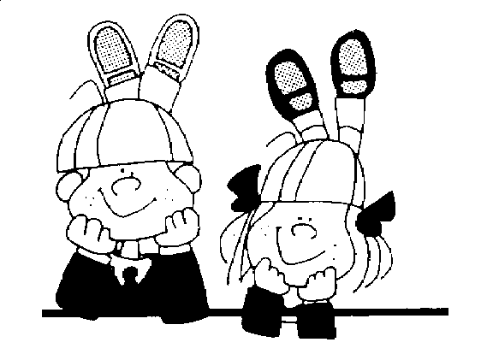

THIS YEAR IN 4-H I WOULD LIKE TO LEARN OR DO THE FOLLOWING:
MY 4-H CLUB

My Club Name Is ______________________
My Club Meets on ______________________
(Day of month)
at ______________________________________
(Name of location)

A 4-H CLUB IS A GROUP IN MY AREA THAT MEETS TO LEARN ABOUT 4-H, WORKS TOGETHER, AND HAS FUN. THE 4-H CLUB HAS ADULT LEADER(S) WHO TELL ME ABOUT EVENTS AND ACTIVITIES HAPPENING IN 4-H. PROJECT LEADERS HELP ME LEARN MORE ABOUT MY PROJECTS.

MY CLUB OFFICERS
PRESIDENT ___________________________
VICE PRESIDENT _______________________
SECRETARY ____________________________
TREASURER ___________________________
CLUB REPORTER ________________________
OTHERS ______________________________

My Club Leader(s) My Project Leader(s)
4-H CLUB FUN
I MAY PARTICIPATE IN FUN THINGS WITH MY CLUB AND ENJOY THE FELLOWSHIP OF OTHER 4-HERS.

FUN THINGS I DID THIS YEAR:
(CLUB ACTIVITIES)
_________________________ Date __________

_________________________ Date __________

_________________________ Date __________

_________________________ Date __________

_________________________ Date __________

_________________________ Date __________

THE FUN THING MY CLUB DID I LIKED BEST:
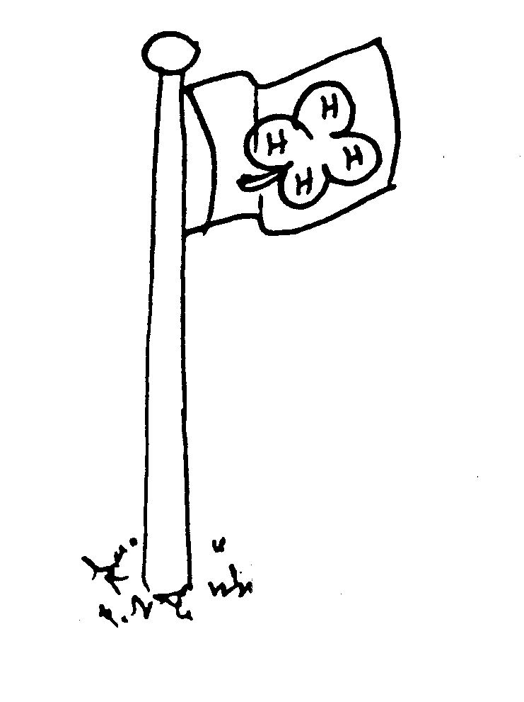
________________________________________________________________________________________________________________________________________________________________________________________________________________________________________________________________________________________________________
COME TO THE FAIR

THE FOND DU LAC COUNTY FAIR IS HELD IN JULY.

DESCRIBE SOME OF YOUR EXHIBITS ENTERED AT THE FAIR:

ENTRY_________________________________________________________________________________________________________________________________________________________________________________________________________________________

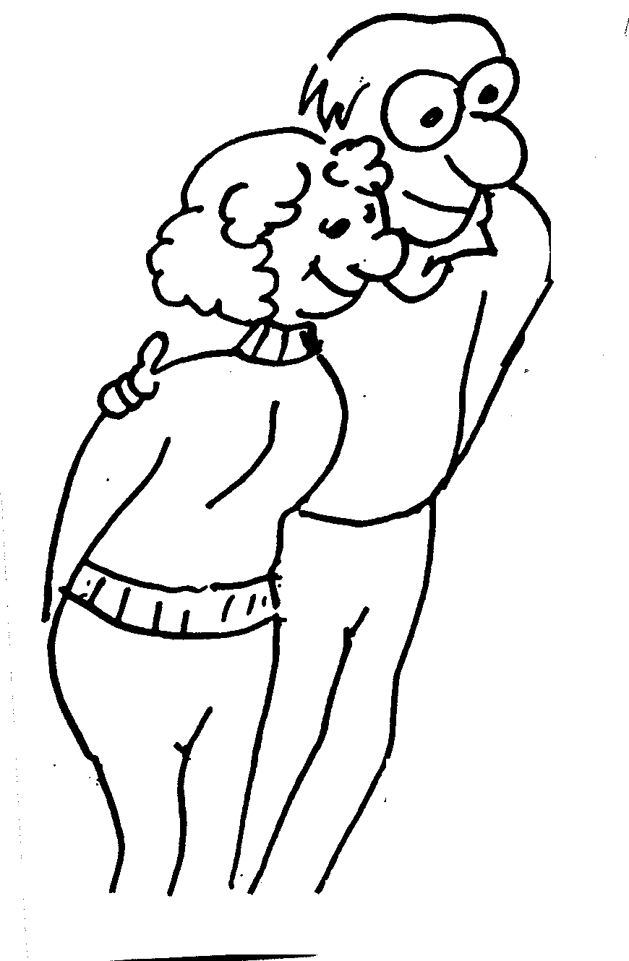
PARENT COMMENTS

___________________________
___________________________
___________________________
___________________________
___________________________
___________________________ ___________________________
“FAIR PHOTOS, CLIPPINGS & MEMORIES”

4-H COUNTY ACTIVITIES
I MAY PARTICIPATE IN ACTIVITIES THROUGHOUT THE YEAR IN MY COUNTY.

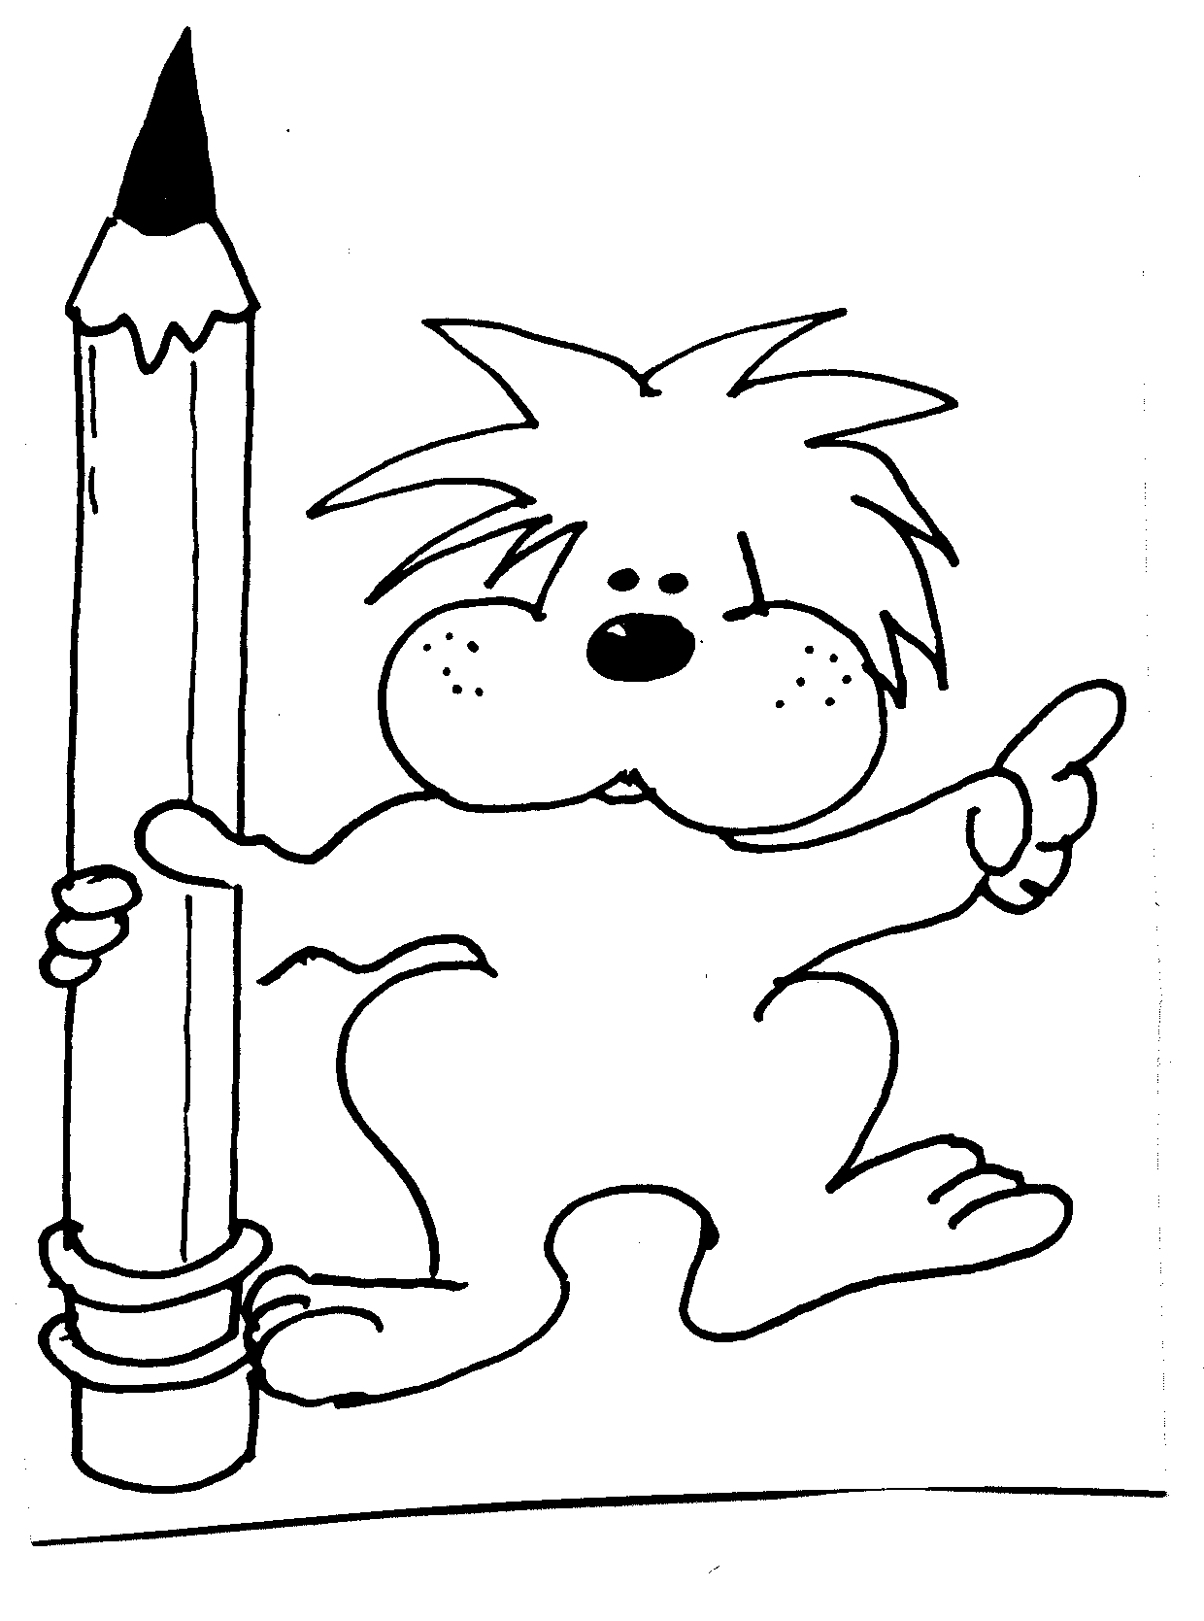
COUNTY ACTIVITIES I WAS IN:
X

BASKETBALL

CAMP

CLOVERBUD WORKSHOP

COUNTY FAIR

FAMILY LEARNING DAY

FASHION REVUE

FOODS REVUE

MUSIC FESTIVAL

PUMPKIN CONTEST
SPEAKING/DEMONSTRATION CONTEST

OTHERS

4-H NOTES

(This page may be used for clippings, pictures, programs, etc.)

4-H NOTES
(This page may be used for clippings, pictures, programs, etc.)



1999 ADAPTED FROM CRAWFORD CO. 4-H CLOVERBUD RECORD BOOK

The University of Wisconsin–Madison Division of Extension provides equal opportunities
in employment and programming in compliance with state and federal law.

