## **CLOVERBUD**

## **RECORD BOOK**

# Name______________________ City ______________

Address ___________________4-H Age __________

(Age as of Oct. 1)

Birth Date _________________

# Parents/Guardian _____________________________

Name of Club _________________________________

## THIS IS ME



### My Hair is ____________________________

My Eyes are __________________________

I am in _________ at ___________________

(Grade) (School)

My favorite Animal is ____________________

My Favorite Food is _____________________

My Favorite Sport is ____________________

More Me

### There are ________ Members in My Family

_________ Brothers _________ Sisters

Family Autographs

____________________________________________________________________________________________________________________________________________________________________________________________________________

##### My Pet

I Have One 

I Don’t Have One 

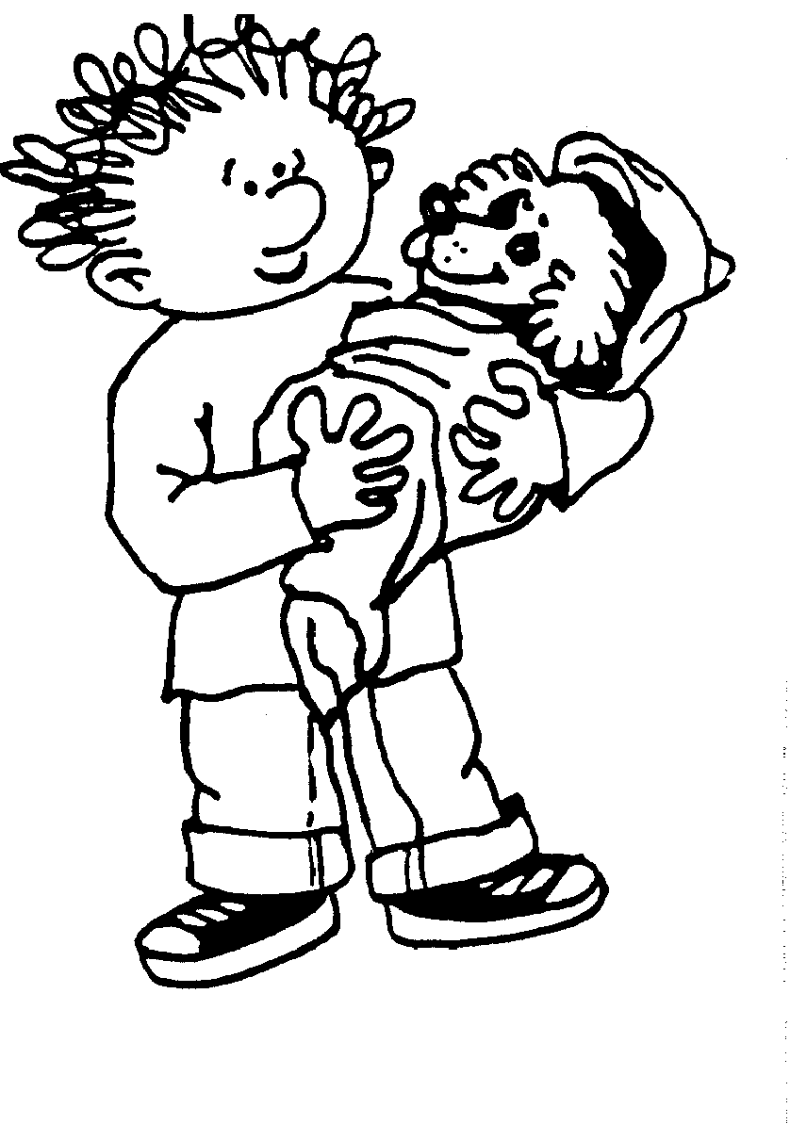

Fun Things I Do With My Pet Are:

Things I Do To Care For My Pet Are:

________________________________________

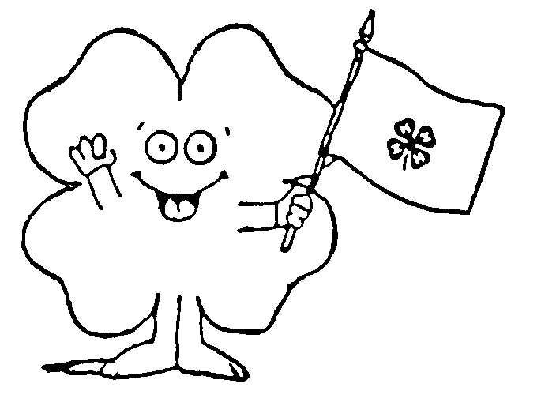

**4-H PLEDGE**

I Pledge My ____________ To Clearer Thinking,

#### My __________________ To Greater Loyalty,

#### My __________________Larger Service, And

My _________________ To Better Living, For

#### My Club, My Community, My Country,

#### And My World.



4-H Club Emblem: The Four-Leaf Clover

4-H Club Colors: Green And White

4-H Club Motto: To Make The Best Better

| I JOINED 4-H BECAUSE: |  |
| --- | --- |
|  | |
|  | |
|  | |
|  | |
|  | |

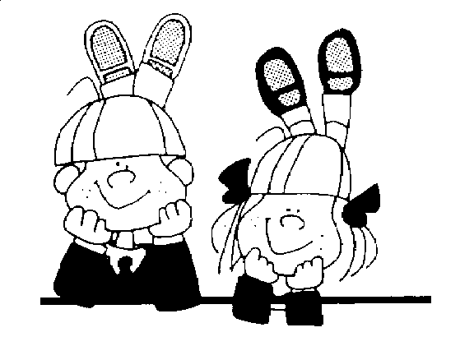

THIS YEAR IN 4-H I WOULD LIKE TO LEARN OR DO THE FOLLOWING:

|  |  |
| --- | --- |
|  | |
|  | |
|  | |
|  | |
|  | |

MY 4-H CLUB

###### My Club Name Is ______________________

My Club Meets on ______________________

(Day of month)

at ______________________________________

(Name of location)

A 4-H CLUB IS A GROUP IN MY AREA THAT MEETS TO LEARN ABOUT 4-H, WORKS TOGETHER, AND HAS FUN. THE 4-H CLUB HAS ADULT LEADER(S) WHO TELL ME ABOUT EVENTS AND ACTIVITIES HAPPENING IN 4-H. PROJECT LEADERS HELP ME LEARN MORE ABOUT MY PROJECTS.

**MY CLUB OFFICERS**

PRESIDENT ___________________________

VICE PRESIDENT _______________________

SECRETARY ____________________________

TREASURER ___________________________

CLUB REPORTER ________________________

OTHERS ______________________________

My Club Leader(s) My Project Leader(s)

|  |  |  |
| --- | --- | --- |
|  |  |  |
|  |  |  |
|  |  |  |

**4-H CLUB FUN**

I MAY PARTICIPATE IN FUN THINGS WITH MY CLUB AND ENJOY THE FELLOWSHIP OF OTHER 4-HERS.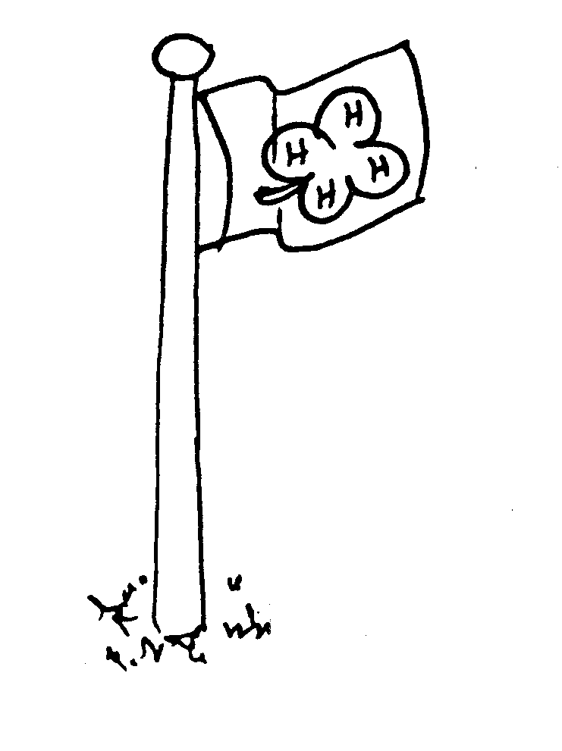

FUN THINGS I DID THIS YEAR:

(CLUB ACTIVITIES)

_________________________ Date __________

_________________________ Date __________

_________________________ Date __________

_________________________ Date __________

_________________________ Date __________

_________________________ Date __________

THE FUN THING MY CLUB DID I LIKED BEST:

**_______________________________________________________________________________________________________________________________________________________________________________________________________________________________________________________________________________________________________________________________________________________**

**COME TO THE FAIR**

THE FOND DU LAC COUNTY FAIR IS HELD IN JULY.

DESCRIBE SOME OF YOUR EXHIBITS ENTERED AT THE FAIR:

ENTRY__________________________________________________________________________________________________________________________________________________________________________________________________________________

PARENT COMMENTS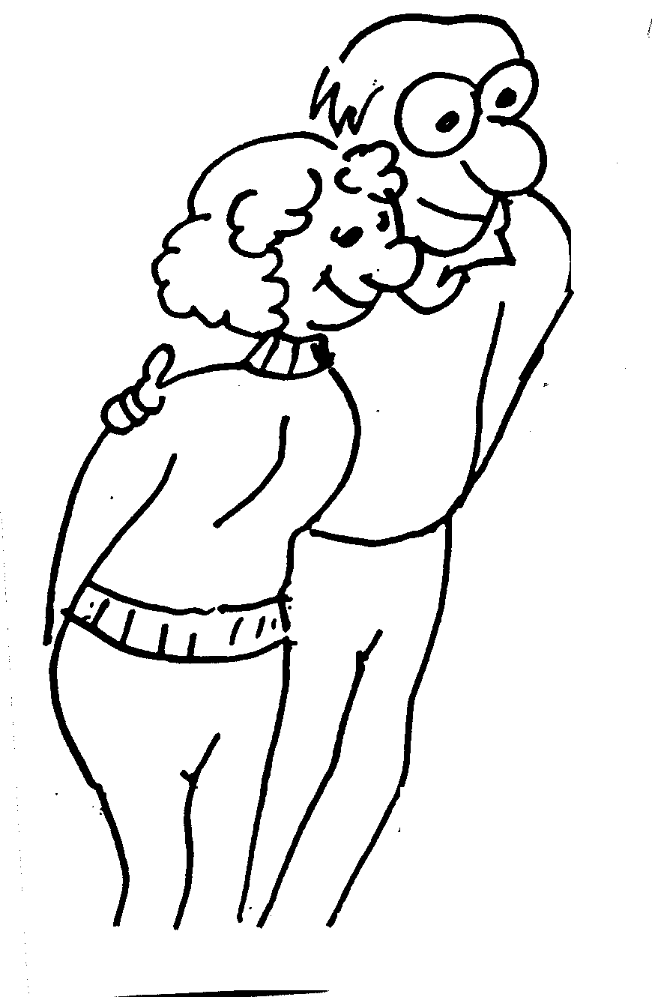

___________________________

___________________________

___________________________

___________________________

___________________________

___________________________ ___________________________

___________________________

**“FAIR PHOTOS, CLIPPINGS & MEMORIES”**

**4-H COUNTY ACTIVITIES**

I MAY PARTICIPATE IN ACTIVITIES THROUGHOUT THE YEAR IN MY COUNTY.

COUNTY ACTIVITIES I WAS IN: 

BASKETBALL 

CAMP 

CLOVERBUD WORKSHOP 

COUNTY FAIR 

FAMILY LEARNING DAY

FASHION REVUE 

FOODS REVUE 

MUSIC FESTIVAL 

PUMPKIN CONTEST

SPEAKING/DEMONSTRATION CONTEST 

OTHERS 

4-H NOTES

(This page may be used for clippings, pictures, programs, etc.)



4-H NOTES

(This page may be used for clippings, pictures, programs, etc.)



1999 ADAPTED FROM CRAWFORD CO. 4-H CLOVERBUD RECORD BOOK

*The University of Wisconsin–Madison Division of Extension provides equal opportunities   
in employment and programming in compliance with state and federal law.*

