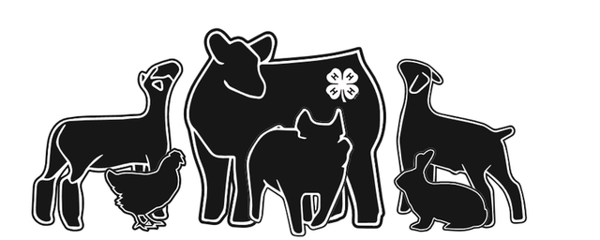

|  | Fond du Lac County  Market Livestock Project  Livestock Project Scholarship Application |
| --- | --- |

* This scholarship is designed to recognize the outstanding efforts of the youth who are currently participating in the Market Livestock Project (beef, market goats, sheep and swine) at the Fond du lac County Fair for a minimum of three years.
* At the time of application, individuals must be a senior in high school or be enrolled in their first year of school at Farm & Industry Short Course, Technical School or 4-year program. Individuals can win this scholarship only once.
* Two letters of recommendation are required to be mailed with the scholarship application. (Please note that recommendations should not come from family members or members of the Market Livestock Committee.)
* Six $500.00 scholarships will be awarded to deserving youth. **l**

Scholarship must be postmarked by ***April 15.*** Mail to:

MLP Scholarship

P. O. Box 1466

Fond du Lac, WI 54936

Scholarships will be distributed after receipt of a copy of the 1st term grades and 2nd term schedule.

Name ___________________________________________________________________________

Year of Graduation_____________________________ High School _____________________________________________________ Parent/Guardian ____________________________________________________________ Address__________________________________________________________________________City ___________________________________________________________ Zip Code ________ Phone Number _______________________________________ Email Address ______________________________________________________ Post-Secondary School Attending _________________________________________________________ Major and Minor ___________________________________________________________________________ Years of participation in the Market Livestock Sale _______________________________________

Years of Participation in:

| Market Beef | _______ | Market Lamb | ________ |
| --- | --- | --- | --- |
| Market Goats | _______ | Market Swine | ________ |

**PLEASE ANSWER THE FOLLOWING QUESTIONS**

*Not exceeding 2 pages, using Times New Roman font with no smaller than a 12 point size.*

1. Why did you first get started in the Market Livestock Project?

2. What are the three most valuable lessons that you learned by being a part of this project?

3. Describe your involvement in school/community/volunteer activities.