FOND DU LAC COUNTY
NOVEMBER HIGHLIGHTS

Supporting Agriculture Professionals in November

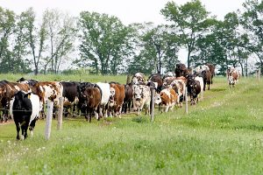

An Eastern Wisconsin Farm Management Update Virtual Meeting for 101 agribusiness professionals, where they learned about prioritizing financial and market decisions to assist their clientele in making informed decisions.

A bi-weekly radio interview for 12,000 Fond du Lac County farmers, agricultural industry persons, youth livestock, and youth dairy where extension agriculture related resources, information, and timely webinars are shared to help them to be connected and supported, and make better informed decisions regarding their farm business operations or youth large animal project.

A Dairy Program Area/Team Facebook social media campaign for 850 plus “joined” members and public where Extension COVID-19 agriculture resources are disseminated for farmers, agribusiness professionals, and others to assist in the decision-making process.

Presentations for dairy farmers, managers, employees, educators, and agribusiness professionals, where participants learned best herd management practices regarding culling dairy replacements to minimize heifer rearing costs and maximize labor, management, and resources. In addition, participants learned how and why to successfully process a calf within the first 24 hours of life to provide a solid foundation for the calf's vigor and vitality.

A series of emails and e-newsletters for farmers, service providers, consultants, and agency staff where they were provided unbiased, university, researched based information about agriculture practices and upcoming events.

A webinar on post-harvest grain storage and handling involving construction, maintenance, and safety.

SELECT UPCOMING EVENTS:
For more visit
fonddulac.extension.wisc. edu/events

Dairy Margin Coverage Program Webinar - Dec 3, 12pm-1pm
The Dairy Margin Coverage (DMC) program is an important risk management tool which dairy producers have access to from the USDA-Farm Service Agency. UW-Madison Division of Extension is providing dairy producers an extra opportunity to help ensure they are making the correct DMC coverage level decision for their operation. Pre-registration is required by emailing scott.reuss@wisc.edu

Using the Estimating Hay Needs and Heifer Enterprise Budget Decision Tools Webinar - Dec 8, 7pm-8:30pm
UW-Madison Extension Cow/Calf Days and Wisconsin Feeder Workshops will be combined to create the Wisconsin Beef Special Edition Webinar Series. Join your local Extension Livestock Program Educators, UW Specialists, and esteemed keynote speakers as they present current topics on beef production.
Register by December 1 at go.wisc.edu/FarmReadyResearch

FOND DU LAC COUNTY NOVEMBER HIGHLIGHTS

Supporting Food Security and Healthy Eating in November

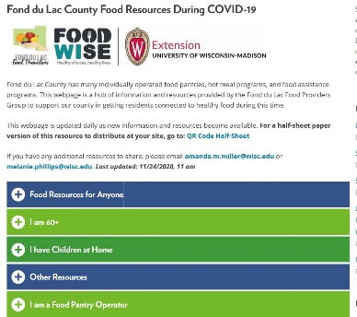
- Development of a food resource hub for the Fond du Lac Food Providers Group that helps local agencies direct community members to local and state food resources, designed to support coordination between local agencies in service of those impacted by this emergency situation (image above, https://fonddulac.extension.wisc.edu/fond-du-lac-county-food-resources-during-covid-19/ ).
COMMENTS FROM THE COMMUNITY:
Virtual Classes on Nutrition at Fond du Lac Boys and Girls Club
“The virtual program went well this summer. I think it was great to have our members interact with your staff members virtually as a fun program! We would be interested in talking to see if you want to come into the club to run a program this school year.”
-Pam

Conducted needs assessment of local food pantries to determine needs and issues related to COVID-19

Development of recorded video lessons for Head Start children to learn about healthy eating

Development of Bitmoji Classroom for elementary school students to learn about healthy topics

A series of virtual classes for community members on food safety, nutrition, and food budgeting

A social media campaign for residents in which cooking and food preparation information is shared, designed to support healthy eating habits during the pandemic.

A series of emails for the Food Providers Group to support local food pantries during COVID-19, designed to support coordination between local agencies and organizations in service of those impacted by this emergency situation.

A series of newsletters for older adults to learn about health and nutrition during COVID.

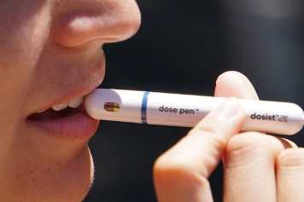
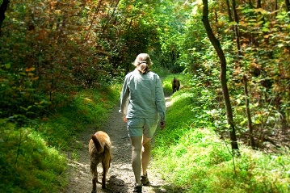
Supporting Health and Mental Health in November

- Resources shared with local health coalition leaders to raise awareness and knowledge on racial and health equity
- Marketing campaign for community members in which influenza vaccination information is shared
- A social media campaign and press release for community members in which holiday food safety information is shared

A series of online lessons for teachers, providing them with science-based information on nutrition, so they can disseminate these resources with students and caregivers.
FOND DU LAC COUNTY NOVEMBER HIGHLIGHTS

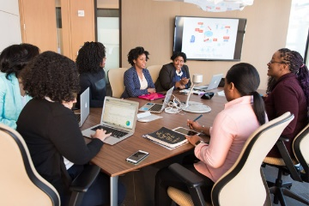
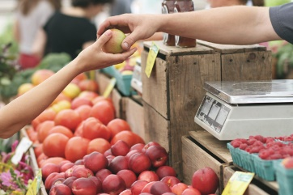
Community Development in November
COMMENTS FROM THE COMMUNITY
Community Development
"Thanks for Saturday. It was really nice to connect with you all and everyone on the call. Reminds me of just how much ambition and thriving black entrepreneurs we have across our state."
- Presentation Participant,
StartUp Wisconsin Week

- A presentation (StartUp Wisconsin Week) in which Extension shared research project results from a study with Black business owners with study participants and community members to spark discussion and get feedback on the future direction of the project.

- A poster session at a statewide conference (Toward One Wisconsin Conference) in which Extension colleagues shared results of the interviews with 48 Black business owners in northeastern Wisconsin.

Youth Development in November
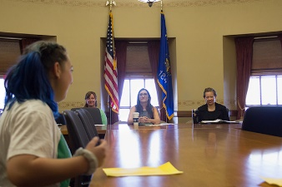
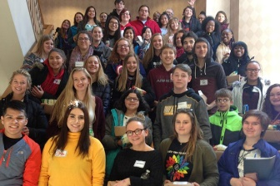
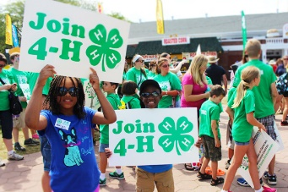
COMMENTS FROM THE COMMUNITY
Positive Youth Development Sessions at the Fond du Lac Boys/Girls Club
“The series was awesome! It was great for getting the youth in each of the groups a chance to learn how to work together and get to know one another better. I thought it was a great break for the youth that we serve from the school work and crazy school year that they have been a part of.”
-Boys/Girls Club Director
of Youth Programs

Virtual meetings for the following programs were held:

- 4-H club and project leaders, where virtual meeting tools were explained, and questions could be asked to support 4-H volunteers in holding virtual meetings.

- FDL Boys/Girls Club where youth applied personal problem solving skills and group development knowledge in an experiential activity-based lesson and the stages of group development to increase their awareness and knowledge in positive communication, trust, and consensus building in order to be more effective in their social/group setting" in the future..

- 4-H club & project leaders and youth, where the WI 4-H Movement and WI 4-H Movement Materials were shared and questions could be asked to support 4-H volunteers in the work they do for 4-H programming.

- 4-H youth members and adult volunteers, where adult volunteers were recognized, budget was determined and business for 20-21 year was discussed and questions could be asked to support 4-H volunteers.

- Trivia night for 4-H Teen Leaders and Youth , where youth were able to learn fun facts while connecting with their peers to have a sense of belonging and to stay active in 4-H.

A workshop for youth attending the statewide Fall Forum (virtual conference) which youth learned problem-solving skills strategies to improve self-efficacy skills

We teach, learn, lead and serve, connecting people with the University of Wisconsin, and engaging with them in transforming lives and communities.

Cindy Sarkady
Area Extension Director

Diana hammer
Community Development Educator

Ron Jakubison
Positive Youth Development Educator

Tracy Keifenheim
4-H Program Educator

Tina Kohlman
Dairy & Livestock Agent

Amanda Miller
FoodWIse Coordinator
Health & Well-Being Educator

Pamela Nelson
FoodWIse Educator

Melanie Phillips
FoodWIse Educator

Patty Percy
Community Garden Coordinator

Pam Bartoli
Tina Engelhardt
Katie Gindt
Cassi Worster
Support Staff

FOND DU LAC COUNTY NOVEMBER HIGHLIGHTS

WHAT’S TO COME: Major planning efforts by Fond du Lac Extension Staff in November

Planning for 2021 Bi-Annual Midwest Manure Summit for dairy producers, managers, agribusiness professionals, agency and governmental personnel, etc. The goal of this effort is to teach individuals the newest and latest researched based technologies and best management practices regarding manure handling and processing, so that they can handle dairy waste in a proficient, efficient, and safe manner while maintaining neighbor and community relations.

Leading the efforts for the planning for and development of eight bilingual Dairy Workers' Skills Training Modules for dairy workers, dairy owner/operators, managers, educators, and agri-business professionals in collaboration with Language Access and Publishing Unit/Learning Store. The goal of this effort is to have resources to teach English and Spanish speakers the "why" behind the daily best management practices, so that they can be more efficient, proficient, and safe in doing their jobs while maintaining animal welfare.

Planning for dairy welfare (December) and dairy replacement (March) virtual meetings as part of the state-wide dairy specialist series for dairy producers and agricultural professionals in collaboration with UW Madison Extension and UW Madison Department of Animal and Dairy Science. The goal of this effort is to share with audience latest research from dairy welfare and dairy replacement specialists and how to implement the research-based management practices on the farm.

