February 26, 2020

Dear 4-H Leader,

•Summer Day Camp is June 21-24th. We are seeking Adult volunteers interested in helping with the camp. Applications will be sent out and available online https://fonddulac.extension.wisc.edu/events-activities/ and deadline has been extended to March 14th. Applications can also be emailed to tracy.keifenheim@wisc.edu. The youth will be contacted to set up interview times. There is a mandatory all staff and counselor training on Saturday, March 21 from 8:30 am-5 pm at Camp TaPaWingo, 915 Tapawingo Rd, Mishicot, WI 54228. If you are unable to attend the all-day training on March 21, you may attend one of the counselor training weekends offered at Upham Woods. The training is offered three different weekends, March 28-29, 2020; April 25-26, 2020; May 2-3, 2020 (there is a $55 charge for the Upham Woods Counselor training that the attendee would be required to pay themselves).

•Please encourage youth to sign up for the Creative Arts Festival on Saturday, March 28th. The registration form is available on our website. Registration is due Monday, March 2nd. https://fonddulac.extension.wisc.edu/events-activities/. Writing, Arts, and Photography entries are to be submitted by 4:30 pm on Friday, March 13th, 2020 to the extension office. Art and writing pieces will be on display the entire day of the festival. Youth can pick up pieces afternoon on March 28th.

• SPRING 4-H LEADER MEETING- The 2020 spring adult leader meeting will be Saturday, April 25 from 9-11 am in room AE-205/206 of Extension Fond du Lac County. The theme is Leadership Blooming! Don’t miss the opportunity to represent your club at the county-level! There will be business, learning, and socializing! Campbellsport, Green Valley, and Ledgers will be providing light refreshments. We hope to see every club there!

• 4-H Basketball Tournament- Saturday, April 4, 2020, at Lomira High School
Games begin at 8 a.m. and continue throughout the afternoon until one team is declared the winner! (Plan to stay until 2 p.m.) The tournament is arranged for members’ enjoyment and recreation. Any club that does not have enough youth to fill a team (5 players) can combine with another club. Please contact Extension if your club would like to combine with another club. If you need an accommodation for a disability to participate in this event, please contact Tracy Keifenheim. All teams must send in a completed registration form (Feb. newsletter) with payment by Friday, March 6th.

• SUPER CRAFT SATURDAY- On Saturday, April 4, you will not want to miss Super Craft Saturday! This event is open to 4-Her’s of all ages and community youth. It gives you the opportunity to try your hand at a variety of craft projects ranging in size from small to large. Bring paintbrushes if you have them. Super Craft Saturday will be held at Ashford Town Hall from 9:00 a.m. to 2:00 p.m. Walk-ins are welcome. For more details or special requests on projects, call JoAnn Hall at 920-904-6786.

•On occasion, we have received requests for a certificate of insurance. This often happens because 4-H is using someone else’s facilities (i.e. school, church) and the facility wants proof there is insurance coverage. Contact Tracy and provide the following information:
- What is the event
- The date of the event
- Location/address of the event
- The name, address, and e-mail of the person to send the certificate to
We will send this information to the UW-Madison risk manager. They will send the certificate to me. You need to allow plenty of time for this chain to be followed when asking for a certificate. We suggest a minimum of 3 weeks for process time. Separate certificates are needed for each location of an event.

•CONTRACTS FOR EVENTS, ACTIVITIES, ETC.- A reminder that Extension employees and volunteers do not have signature authority to sign event contracts with an external party on behalf of Extension. All contracts for events taking place must be signed by Purchasing Services at UW-Madison. This applies to any space use agreements (including both zero-cost rentals and rentals requiring a fee) and catering contracts. Note: this does not apply to 4-H club/project use of space at the Extension office. If you have questions about this policy please feel free to contact Tracy at tracy.keifenheim@wisc.edu or 920-929-3170.

• You can now register your club for the Adult and Teen Leaders county fair food stands. Note that the Adult Leader Food Stand shift times have changed. At your March meeting discuss the options for both food stands with your members. These are major fundraisers for the county 4-H program, benefitting all clubs, members, and the communities in which they reside. Time slots for the food stand shifts can be filled by going to https://fonddulac.extension.wisc.edu/events-activities/ under 4-H Fundraising Events

Sincerely,
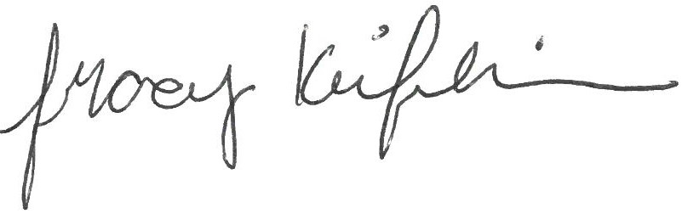
Tracy Keifenheim
4-H Program Coordinator
UW-Madison Division of Extension, Fond du Lac County
cc: Executive Board, TLA Advisor, Horse Project President
enc: Project meeting Plan

Idea Corner
We would love to include something fun, educational, or different that your club has tried in the next Leader Letter! The “Idea Corner” can be a regular article in our Leader Letter where leaders share new ideas that were successful and/or a helpful resource where you found that idea! You can submit a paragraph yourself or you can ask a youth to write it up. Your idea doesn't have to be a huge, groundbreaking idea, just something that you feel that other leaders might appreciate. Remember, sometimes "the little things are the big things." -- Author Wilferd A. Peterson. Please submit ideas for next month’s Leader Letter by March 15th to Tracy at tracy.keifenheim@wisc.edu. Anyone who has submitted an idea will be entered in a drawing for prizes two times a year and will be pulled at the April and August General Leader meetings.
RESOURCE OF THE MONTH
Project meeting Plan enclosed. This is a great template for project leaders to organize project meetings. It would also be a great tool for a Youth Leader to help plan a project meeting. General leaders could also use it to help improve club meetings. It always helps to have a written plan. I highly encourage you to make copies and share with your club project leaders and youth leaders! This material is also part of the VIP training.

