December 13, 2019

Dear 4-H Leader,

I hope that December is going well for all of you. It is such a busy and fun-filled month! While we do not have a Family Times newsletter for January, I do have a few updates for you.

•The financial forms are available on the website (https://fonddulac.extension.wisc.edu/4h/county-4-h-associations/4-h-leaders-association/). If you are seeking reimbursement or making a deposit to/from the Fond du Lac County 4-H Adult Leaders Association, these are the forms that you need to submit, along with an original receipt. All transactions can go directly to JoAnn Maedke, the Adult Leaders Association treasurer. JoAnn's address is N4449 Northview Road, Eden, WI 53019-1301. You may also continue to bring reimbursements/deposits into the office and we will pass them along to JoAnn. JoAnn will be working on transactions approximately twice a month, so please plan accordingly.

•All clubs are strongly encouraged to use the deposit and reimbursement forms available here: https://fonddulac.extension.wisc.edu/4h/club-leadershipa/ under Treasurer Forms. Remember that all transactions must have a form filled out for them and all reimbursements require an original receipt. Please review the Financial Best Practices document on our website: https://fonddulac.extension.wisc.edu/4h/4-h-resources-2/. The new year is a great time to implement better financial practices.

•Family Learning Day is Saturday, February 22nd. Please look for more information to come out in January and February. Please register as soon as possible for sessions as they do fill up rather quickly! A session for annual charter training and new volunteer training will be offered for any adults who missed the training in November. Information will be posted online as well under the events and activities page on the 4-H extension website.

•Summer Day Camp is June 21-24th. We are seeking Adult volunteers interested in helping with camp in addition to Camp Counselors. Applications will be sent out and available online and due to the office by February 15th. Applications can also be emailed to fdl4hcamp@gmail.com. Interviews will be late Feb/early March. The youth will be contacted to set up interview times.

•Please encourage youth to sign up for the Creative Arts Festival on Saturday, March 28th. The registration form is available on our website. Registration is due Monday, March 2nd. https://fonddulac.uwex.edu/events-activities/. Writing, Arts, and Photography entries are to be submitted by 4:30 pm on Friday, March 13th, 2020 to the extension office. Art and writing pieces will be on display the entire day of the festival. Youth can pick up pieces afternoon on March 28th.

•Please don’t forgot to periodically check the mail slots in the extension office for club mail and reminders. Many slots have awards from the Adult Leaders banquet and materials from Officer Training. You can always call the office to check if there is anything in the club mail slot.

•Thank you for inviting me to your club meetings. My goal has been to attend as many meetings before my leave. So far I have attended Armstrong, Adult Leaders Board, Campbellsport, Creative Clovers, Forest Hills, South Byron, Springvalley, New Horizons, and Teen Leaders Association in addition to several committee meetings. Starting December 16th I will be out of the office on leave and returning in February. I have a few club meetings scheduled once I return and into the spring. If there is a meeting that you would like me to attend, please let me know. I would love to lead an icebreaker or an educational activity for your group.

•Finally, you haven't seen the following resources provided by National 4-H and WI 4-H, I strongly recommend you check them out.

---Inspire Kids to Do Holiday Activity Guide: https://4-h.org/inspire-kids-to-do/
Click where it says "Download Now."

---Wisconsin 4-H Cloverbud Learning Activities: https://fyi.extension.wisc.edu/wi4hcloverbuds/activity-plans/
Click where it says "Unlock Activities."

---Essential Elements of Positive Youth Development: Online training for leaders
Each module is about 7-10 minutes long and available on 4Honline.
https://4h.extension.wisc.edu/files/2018/08/4HOnline-Essential-Elements-Training-For-4H-Volunteers.pdf

Dates for 2020
Jan 9 – 4-H Executive Board
Feb 15 – Deadline to apply for camp counselor and adult volunteers
Feb 22 – Family Learning Day
March 2 – Deadline for Creative Arts Festival entry
March 13th- Writing, Arts and Photography entries due for Creative Arts Fest
March 28- Creative Arts Fest
April 25 – 4-H Leaders Association meeting (9-11 am)
June 21-24– Summer Camp
July 9 & 14 – Pre-fair judging days
July 15-19 – FDL County Fair

Sincerely,
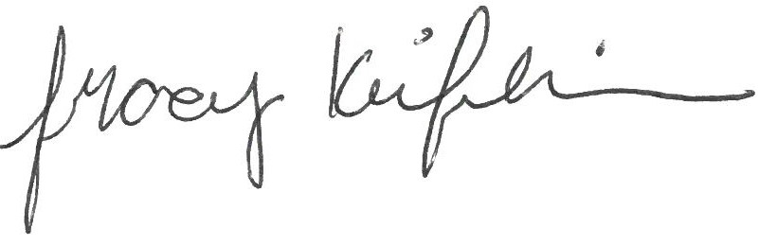
Tracy Keifenheim
4-H Program Coordinator
UW-Madison Division of Extension, Fond du Lac County

cc: Executive Board, TLA Advisor, Horse Project President
enc: Fond du Lac County 4-H Adult Leaders Deposit and Reimbursement Forms,
Club Deposit and Reimbursement Forms

Idea Corner
We would love to include something fun, educational, or different that your club has tried in the next Leader Letter! The “Idea Corner” can be a regular article in our Leader Letter where leaders share new ideas that were successful and/or a helpful resource where you found that idea! You can submit a paragraph yourself or you can ask a youth to write it up. Your idea doesn't have to be a huge, groundbreaking idea, just something that you feel that other leaders might appreciate. Remember, sometimes "the little things are the big things." -- Author Wilferd A. Peterson. Please submit ideas for next month’s Leader Letter by February 15th to Tracy at tracy.keifenheim@wisc.edu. Anyone who has submitted an idea will be entered in a drawing for prizes two times a year and will be pulled at the April and August General Leader meetings.
RESOURCE OF THE MONTH
Wisconsin 4-H Town Halls
Starting in 2020, Wisconsin 4-H will be hosting quarterly Town Hall meetings via Zoom video chat, where volunteers and staff can join to hear updates from the State Leadership Team and learn about things going on in the program. This has been a powerful way of creating a shared experience across our entire state. All 4-H volunteers and families are invited to join in! The first Wisconsin 4-H Town Hall was held on October 29th, 2019. The recording is now available to view for those who were unable to listen live. You can find the recording here: WI 4-H Town Hall October 29, 2019 recording.
Connection information for each Town Hall meeting will be unique and will be emailed out to currently enrolled 4-H volunteers.
- January 16th, 7:00-8:00 p.m.
- April 14th, 7:00-8:00 p.m.
- July 14th, 7:00-8:00 p.m.
- October 6th, 7:00-8:00 p.m.

