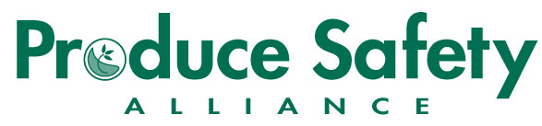
Produce Safety Alliance Grower Training Course

UW-Extension and Safe Wisconsin Produce will host a Produce Safety Alliance-sponsored Grower Training on 26 February 2018, at the UW-Fond du Lac Campus University Center, Room 113/114 (400 University Avenue, Fond du Lac, WI 54935), from 7:30 a.m. to 5:00 p.m.

Contact Information
Full Name:
 |  | First Name |  |  |  | M.I. |  | Last Name
Farm Name:
Farm Address:
 |  | Street |  |  | City |  |  |  | State | Zip
Mailing Address:
 |  | Street |  |  | City |  |  |  | State | Zip
Email: |  |  | Phone: |  |  |  | Preferred Contact Method:

Number Attending
Number(s) Attending: |  |  |  | x $60 each = |  |  |  | Total Payment Required
 | Lunch Choice(s): |  | Turkey Cheddar Crazin
 |  |  | Tuscan Chicken
 |  |  | Southwest Chicken
 |  |  | Vegetarian

Registration Details

Registration deadline is February 19th, 2018 (Depending on available seating, walk-in registrations may be allowed). Payment by check only. Make checks payable to: WI-DATCP.

You will receive a confirmation e-mail or letter once your registration form and payment are received.

- U.S. Mail option: Return this form and any payment via U.S. Mail to: WI-DATCP, Box 93178, Milwaukee, WI 53293-0178

- In-Person option: Return this form and payment in person to: UW-Extension, Rm. 227, Admin./Extension Bldg., 400 University Dr., Fond du Lac, WI 54935, ask for Tina E.

Questions?
The Produce Safety Team are available to assist with any questions about this Grower Training Course, or future courses in other areas, and can be reached by phone at (608) 224-4511, or email at safeproduce@wi.gov.

